Executive Committee Meeting
Yoga Society of New York
Minutes for
Tuesday 4:00, March 29, 2016 at BSC Office
Present: Kiranavali (Carol Rollinger), Kamala Kant (Scott Moss), Purnima (Margaret Dillsaver), Donna Carlisi-Ayad
Present on GoTo Meeting: Shanta (Bruce Bulkin), Nandini (Lindsay Stroh), Sarasvati (Silvia Donates)
Proposed Agenda:

- Social Media Marketing committee report on their progress
  - Postponed until next week at 4:15

- Tent Cabins
  - Recommendations from the Buildings and Grounds
  - Vision is to build one this week another next week and maybe 6 more by September? As per available funding
  - Latest email from Scott
    - Kamy is reviewing regarding no permit needs. Upper screens or lower screens is a matter of our preference. Original idea last year was 1/2 wall and the rest of wall was screen with a permanent roof. The way you drew them was more how Omega had them styled. The $600 estimate for the flat roof (not peaked in the middle) Jerry upon further evaluation did not feel would be as attractive. The $1000 estimate became $1400 with the bigger overhang and getting the actual prices vs. on top of his head cost.
    - Hi Everyone, Not to add any complication to our discussion today on the tent cabins, but I do want to report on suggestions made by a healer who was here yesterday. This is just a report....
His name was Gene Guru (http://www.genegurumiraclehealer.com/home/). Emil Andrews met him last year at the Whole Life Expo in NY and suggested he visit the ashram. He came for lunch and stayed through dinner. He has his own ashram in Peru, which he is still building. I found him to be very genuine and caring. Someway the "tent cabins" were mentioned and I walked him over to the site that the B & G had just visited on Saturday. He said it was an excellent location, good energy.
But he suggested a different style roof than that shown in Jerry's drawings. He recommended that if we can, to build the roof using the special angle used in the pyramids: 51.84 degrees. The roof would then look like an inverted Agni Hotra copper pot. He also said to try to put a little copper at the very pinnacle of each cabin, and to have the "front" door open due south. If we feel so inclined, we can also circle each cabin with natural stone and plant herbs in that circle. He said these small adjustments will make the cabins have very good benefit for the occupants.
He also looked at the flow of the water which may pass downhill past the cabins and strongly suggested that each cabin be elevated 12-18inches above the ground, with concrete footings to hold them firmly in place. Emil asked him how far apart they should be from each other and he said 5 meters apart would be okay.
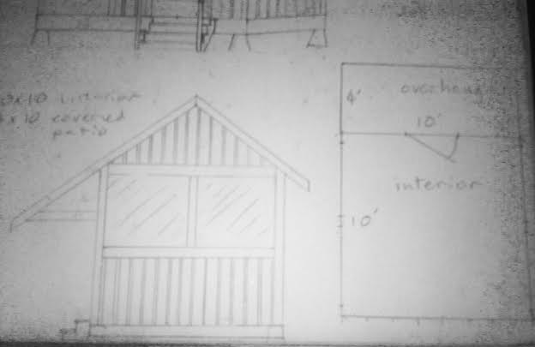
He also said that in that area there are a lot of dead trees (weirdly he could tell even tho there are no leaves on the trees). He said to take down those trees for the practical reason that they could fall and damage the cabins.
That's it...Just FYI..Om Shantih, Purnima
    - Specs as per Jerry
      - Dimensions would be-10’ by 10’
      - All screens, no windows
      - Small detached- deck on ground no railings
      - Front door and maybe a back door with an overhang
      - Following Vastu if we can
        - Build odd number of cabins
        - Door facing right way as per Vastu
      - The first one will be set into the woods kind of facing Shanti Sadanam
      - Discussed overhang for window protection from rain or shutters of some sort
      - Shingled roof
      - Concrete block act as foundation
      - Should take 5 days
      - Will cost 1,400.00
      - Some for staff -discussion of intention is to save some for guests, initial ones will be for staff, offset by not having to put staff into dorms
      - Jerry- jerrijig@gmail.com
      - EC approved this first seasonal cabin and will start tomorrow on this prototype
        - Stained dark to match nature around it

- Brookhaven's "hold harmless forms", waivers, etc. -postponed until next week
  - Follow up on receiving and reviewing

- Other agenda topics
  - Survey
    - Surveyor will come to explain his estimate
      - John Demario- Surveyor of Hudson Valley Services
        - Elmsford, NY, lives locally
        - Will survey our perimeter property lines
          - Will locate old pipes
          - Will present his findings then
          - He will run traverse lines
          - Went to Goshen to check out past surveys and history
          - We have about a 2000 linear feet line
          - He will put a flag 100 feet
        - The estimate is about 6,400.00 tops
          - It is possible if it takes less time it may cost less
          - It is a written estimate
        - A check of 100.00-150.00 for his initial work will be sent to John as a courtesy if we do not hire him
    - We will get another estimate
      - Discussion on who to get other surveys from. Tom Dupre?
    - Scott suggests we get septic survey estimates also for Shanti Sadanam
    - Who has all the surveys and maps ever done at Ananda- Purnima

  - Carpet estimate details
    - To be installed on April 18th
    - Bharati and Krishna picked out a color
      - Gallery, mediation, and reception area room will all be done
    - 894.00 for lobby
    - 5,500.00 for the rest
  - Yoga School request for props
    - They are requesting 100% payment of these props for all yoga classes from YSNY (728 per year)
      - EC is asking what percentage is YSNY and Ananda Yoga
      - Only YTT and specific workshops are under International Schools
      - No rentals are Ananda Yoga
      - Nikki can research payment history
      - Typically it is which entity has the money
      - What is the total cost?
ITEMS IN YOUR CART |  | QTY | PRICE | TOTAL
 | 4'' Foam Yoga Block  Color: Blue | 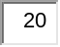 | $7.99 | $159.80 | 
 | Extra Heavy Mexican Yoga Blanket  Color: Brown |  | $29.99 | $599.80
 | YogaAccessories Premium Weight Yoga Mat  Color: Green |  | $19.99 | $399.80
 |  |  | Subtotal | $1,159.40
 |  |  | Discount | $499.80
 |  |  | TOTAL | $659.60
Note: Total does not include tax, shipping, and handling rates. These will be calculated during checkout.
      - Begin to document which are classes are which on program planning
        - Discussion of which classes and events are YSNY and which are ISEWU
        - Look at asterisks on Ananda ashram events page those are ISEWU
      - We will do a split 159.00 Yoga Schools, 500.00 YSNY
        - Scott will contact Nikki ( 25%)
  - Grievance Officers
    - Shantananda- Chairman, Tara, possibly Jivani, Bonnie
      - Shant will contact Tara who may follow through to contact Jivani (Nancy) and Bonnie
      - Nand will assist in setting it up peace@ananda.org that will forward to a Gmail that Shant will set up asap, contact via his cell phone will happen also
      - Send this to HRC as soon as this is set up
      - Discussion on timeliness of current situation
      - Need a form asap
      - Need directives on this process
      - Attendance to program will need to happen
      - Alex Dupre may be able to be the logistical coordinator and he gives the initial form and starts the process we put in place
      - Nand and Shant will work on the initial form
    - Will discuss first step to present a grievance who listens and gives the form to fill out
  - Charka conversation
    - April 8th meeting with Kiranavali and Scott to work with him to do fundraising with him and his dance community to do fundraising for his apartment as part of the Shanti Sadanam

